Backup & restore lab
Site  - MC3 Lab □ | Pick a backup device  - =  - folder __f\backtest________ □ | OS  - Windows 7 □

- Using your command line skills
Process | ‘DOS’ Command
- Create a directory named backtest on your device to be backed up  - Copy a few dll files into ‘backtest’. | 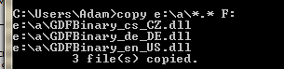
- Back up your files to the Backup device.  - Delete them from backtest | 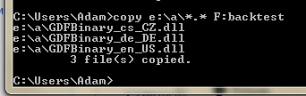
- Restore them to backtest. | 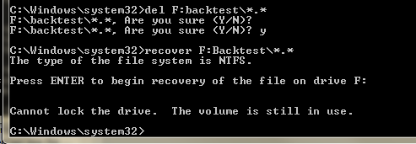

- Use the official Windows backup to back up the files to the backup device

Process | Snip from Windows Explorer
- Follow the wizards to back up your files to the Backup device.  - Delete them from backtest | 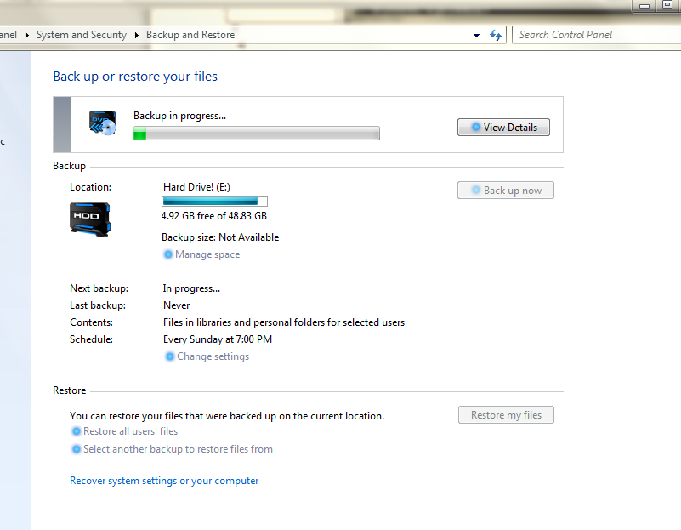
- Follow the wizards to restore them to backtest. | 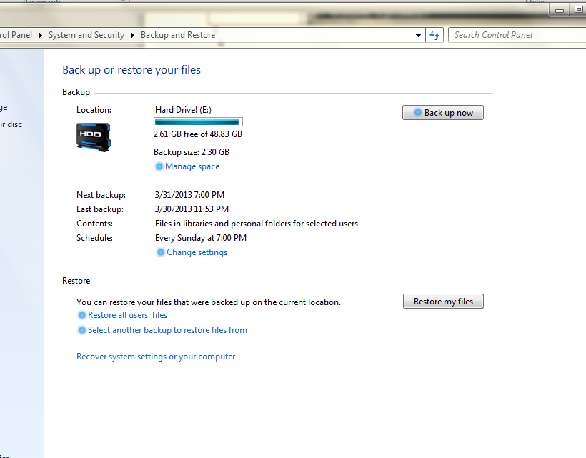

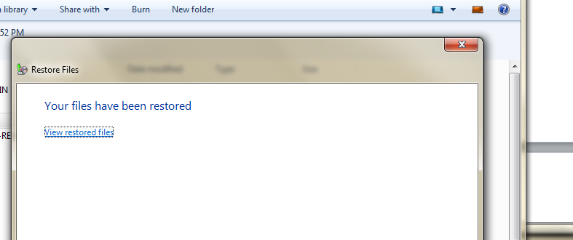

- If this were a real backup on your PC at home or work, what files would you include? Why would you include them?
Pictures bill tax information scanned important documents of my kids and school work

